Chapter 27-2

java collections framework

Queues

- A queue is a data structure consisting of a list of elements to which insertions are made at 1 end called the back, and deletions of elements are made at the opposite end called the front.
- A queue is a FIFO (first-in-first-out) list in that the first element that enters a queue is the first element removed from the queue.
- Unlike the Stack where you delete and insert from the same end, a Queue it is like a waiting line where you insert in the back and delete in the front.

----------------------------------------------------------------------------------------------------------------------------
Usage: public boolean offer(E item)
Post: item inserted at the back of the queue, if possible.
Return: true if it was possible to add the element to this queue, else false

Usage: public E poll();
Post: Head of this queue removed if nonempty queue.
Return: The head of this queue, or null if this queue is empty

Usage: public E peek();
Return: The head of this queue, or null if this queue is empty
----------------------------------------------------------------------------------------------------------------------------
Figure 27-2-1. API for Interface java.util.Queue<E>.

- Java provides no Queue class. However, in JDK1.5, class java.util.LinkedList implements the java.util.Queue interface, so we can use LinkedList to create a queue.

//Example 27-2-1
import java.util.Queue;
import java.util.LinkedList;
class Demo
{
public static void main(String[] args)
{
Queue<String> q = new LinkedList<String>(); //line 8
q.offer("John");
q.offer ("Paul");
q.offer ("George");
q.offer ("Ringo");
System.out.println("There are "+q.size()+" elements");
while (!q.isEmpty())
{
String name= q.poll();
System.out.println(name);
}
}
}

Class PriorityQueue

- A PriorityQueue is a queue, except that each element in the queue has an associated priority.
- Conceptually, a PriorityQueue is a queue with many subqueues, one for each priority. When we add an element to a PriorityQueue, the element is added to the end of the subqueue with the same priority as the element to be added. When we remove an element from a PriorityQueue, the first element in the subqueue associated with the top priority is removed.
- Class PriorityQueue implements the Queue<E> interface.
- By default, a PriorityQueue orders its elements according to their natural ordering using Comparable<E>. Thus, by default, a type T cannot be used with a PriorityQueue using the natural ordering unless T implements Comparable(T).
- By default, a PriorityQueue defines a minimum priority queue. That is, the element with the least value is assigned the highest priority, and thus is removed from the queue first. If there are several elements with the same highest priority, a PriorityQueue breaks the tie arbitrarily. This means don't assume a particular priority for a particular subqueue.
- A priority queue is unbounded. As elements are added to a priority queue, its capacity grows automatically.

----------------------------------------------------------------------------------------------------------------------------
Usage: public PriorityQueue()
Post: The PriorityQueue initialized to empty.

Usage: public PriorityQueue(Collection<? extends E> c)
Post: The PriorityQueue initialized to the elements in c.
----------------------------------------------------------------------------------------------------------------------------
Figure 27-2-2. API for some constructors in class PriorityQueue<E>

//Example 27-2-2
import java.util.PriorityQueue;
class Demo
{
public static void main(String[] args)
{
PriorityQueue<Integer> q = new PriorityQueue<Integer>();
q.offer(2);
q.offer(3);
q.offer(5);
q.offer(1);
q.offer(4);
System.out.println("There are "+q.size()+" elements");
while (!q.isEmpty())
System.out.println(q.poll());
}
}

The Comparator<E> interface

----------------------------------------------------------------------------------------------------------------------------
Usage: public PriorityQueue(int initialCapacity, Comparator<? super E> c)
Post: The PriorityQueue initialized to empty with the specified initial capacity. Its elements are ordered according to the specified comparator c.
----------------------------------------------------------------------------------------------------------------------------
Figure 27-2-3. API for some constructors in class PriorityQueue<E>

----------------------------------------------------------------------------------------------------------------------------
Usage: int compare(E item1, E item2)
Return: A negative integer, zero, or a positive integer as the first argument is less than, equal to, or greater than the second argument

Usage: boolean equals(Object obj)
Return: Indicates whether some other object is "equal to" this Comparator
----------------------------------------------------------------------------------------------------------------------------
Figure 27-2-4. API for Interface Comparator<E>.

- Here are the differences between interface Comparator<E> and interface Comparable<E>:
- Comparator<E> is in java.util, while Comparable<E> is in java.lang.
- Comparator<E> specifies 2 methods, compare and equals, while Comparable<E> specifies 1 method, int compareTo(E item). Note that method compare takes 2 arguments, while method compareTo takes 1.
- Comparable<E> imposes a total ordering on the objects of each class that implements it. This ordering is referred to as the class's natural ordering, and the class's compareTo method is referred to as its natural comparison method. On the other hand, Comparator<E> specifies a comparison method compare, which imposes a total ordering on some collection of objects.

//Example 27-2-3
//Demo.java
import java.util.*;
public class Demo
{
public static void main(String[] args)
{
PriorityQueue<Integer> q = new PriorityQueue<Integer>(10, new LargestIsHighest());
q.offer(2);
q.offer(3);
q.offer(5);
q.offer(1);
q.offer(4);
System.out.println("There are "+q.size()+" elements");
while (!q.isEmpty())
System.out.println(q.poll());
}
}
class LargestIsHighest implements Comparator<Integer>
{
public int compare(Integer x, Integer y)
{
if (x < y) return 1;
else if (x == y) return 0;
else return -1;
}
}
// opposite to how you would normally write compareTo to flip the ranking to a max queue

The Set<E> Interface

- A List, a Set, and a Queue are all Collection objects.
  - While a List and a Queue allow duplicate elements, a Set does not.
- The Set interface extends the Collection interface.
  - It does not introduce new methods or constants, but it stipulates that an instance of Set contains no duplicate elements.

The HashSet<E> Class

- The HashSet class is a concrete class that implements Set.
- It can be used to store duplicate-free elements.
- It uses a hashing scheme to efficiently store and retrieve elements in the collection, running at O(1) efficiency.
- The elements stored in a HashSet are not ordered in any way.

---------------------------------------------------------------------------------------------------------------------
Usage: public HashSet()
Post: A new, empty HashSet constructed.

Usage: public HashSet(Collection<? extends E> c)
Post: A new HashSet containing the elements in the specified collection c constructed.
---------------------------------------------------------------------------------------------------------------------
Figure 27-2-5. API for some constructors of class HashSet.

//Example 27-2-4
//Demo.java
import java.util.*;
public class Demo
{
public static void main(String[] args)
{
HashSet<String> hs = new HashSet<String>(); //line 8
hs.add("London");
hs.add("Paris");
hs.add("Rome");
hs.add("Beijing");
hs.add("Paris"); // not added but no error is thrown
System.out.print("The original collection: ");
System.out.println(hs);
System.out.print("Enter a string to be removed from the collection: ");
Scanner f=new Scanner(System.in);
String s=f.nextLine();
if (hs.contains(s)) hs.remove(s);
else System.out.print("No such string in collection");
System.out.print("The modified collection: ");
Iterator<String> iter = hs.iterator();
while (iter.hasNext())
System.out.print(iter.next() + " ");
System.out.println();
}
}
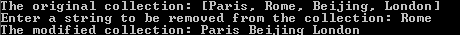

//Example 27-2-5
//Demo.java
import java.util.*;
public class Demo
{
public static void main(String[] args)
{
HashSet<Circle> v=new HashSet<Circle>(); //line 8
v.add(new Circle(2)); //line 9
v.add(new Circle(2)); //line 10
System.out.println(v);
if (v.remove(new Circle(2))) System.out.println("removed"); //line 12
else System.out.println("not removed");
}
}
class Circle
{
private double radius;
public Circle()
{
radius = 0.0;
}
public Circle(double rad)
{
radius = rad;
}
public String toString()
{
return "Radius: " + radius;
}
public boolean equals(Object obj)
{
if (obj instanceof Circle)
{
Circle c=(Circle)obj;
if (radius==c.radius) return true;
else return false;
}
return false;
}
}
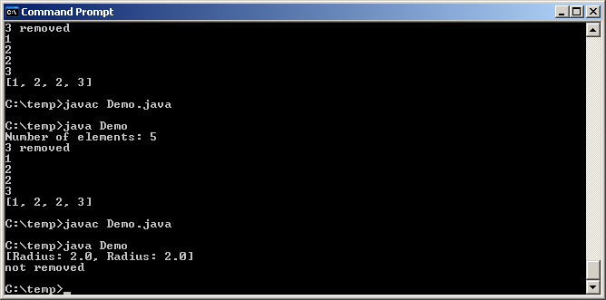

Method hashCode

- To search for an element in a HashSet, the hashing scheme computes the element's location in the collection; thus no searching is required and the operation is O(1)
- To compute an element's location, the hashing scheme makes use of a method named hashCode
- Java mandates that if 2 objects are equal according to the equals(Object) method, then calling the hashCode method on each of the 2 objects must produce the same result.
  - Or, equivalently, if the hashCode method on each of the 2 objects produces different results, the 2 objects cannot be equal according to the equals(Object) method.
- Consequently, to determine object equality, methods such as contains and remove of a HashSet invoke method hashCode first. If 2 objects produce different hashcodes, they cannot be the same object and method equals will not be invoked. Only when 2 objects produce the same hashcodes will method equals be invoked.
- Class Object defines method hashCode to perform the hash code calculation:
public int hashCode()
The implementation of this general hashCode method converts the internal address of an object into an integer value. This has limited application because 2 different objects will normally have 2 different values for hashCode, even if they store the same data value.
- Many Java classes such as String, Integer, and Double override hashCode with implementation that are based on the data in the object.
- To fix Example 27-2-5, let us add the following method to class Circle.
public int hashCode()
{
return (int)radius;
}
- Compile and run Example 27-2-5:
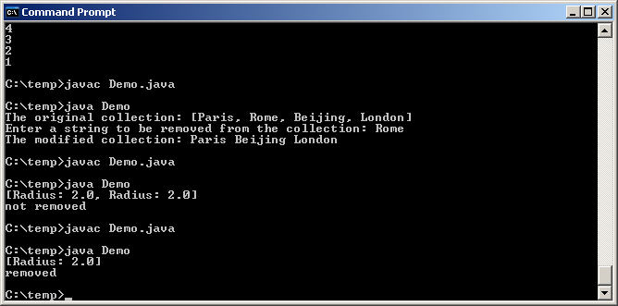

Interface SortedSet<E>

- The SortedSet interface extends the Set interface.
- The SortedSet interface guarantees that the elements in the set are sorted.

---------------------------------------------------------------------------------------------------------------------
Usage: E first()
Return: The first (minimum) element currently in this ordered set.
Exeptn: Throws NoSuchElementException if set is empty

Usage: E last()
Return: The last (maximum) element currently in this ordered set.
Exeptn: Throws NoSuchElementException if set is empty

Usage: SortedSet<E> headSet(E ele)
Return: A SortedSet that contains elements in this SortedSet which are < ele.

Usage: SortedSet<E> tailSet(E ele)
Return: A SortedSet that contains elements in this SortedSet which are >= ele.
---------------------------------------------------------------------------------------------------------------------
Figure 27-2-6. Methods specified in the SortedSet interface.

Class TreeSet<E>

- Like a HashSet:
  - A TreeSet can be used to store duplicate-free elements.
  - A TreeSet supports the operations specified in the Set interface.
- Unlike a HashSet:
  - A TreeSet implements the SortedSet interface as well.
  - The elements in a TreeSet are ordered.
  - A TreeSet uses a binary search tree scheme (instead of a hashing scheme) to efficiently store and retrieve elements in the collection, running at O(log n) efficiency.

---------------------------------------------------------------------------------------------------------------------
Usage: public TreeSet()
Post: TreeSet initialized to empty. The elements inserted are ordered according to the natural ordering of its elements. E must implement the Comparable interface.

Usage: public TreeSet(Collection<? extends E> c)
Post: TreeSet initialized to contain the elements in c. The elements are ordered according to the natural ordering of its elements. E must implement the Comparable interface.

Usage: public TreeSet(Comparator<? super E> c)
Post: TreeSet initialized to empty. The elements inserted are ordered according to the compare method specified in the comparator. E does not need to implement the Comparable interface, because ranking of elements will be based on c, the Comparator.
---------------------------------------------------------------------------------------------------------------------
Figure 27-2-7. API for some constructors of class TreeSet.

- We can use either a HashSet or a TreeSet to store elements. The decision as to which one to use is typically based on the following:
  - Many HashSet methods run at O(1), while the corresponding TreeSet methods run at O(log n).
  - HashSet elements are not ordered, but TreeSet elements are.
- Once the decision of whether to use a HashSet or a TreeSet has been made, we must turn our attention to the class type E of the elements to be stored in the collection to make sure that it works with the selected collection:
  - The class type E of the elements used with a HashSet
    - Does not need to implement Comparable, because the elements in a HashSet are not ordered in any particular way.
    - Does need to override method hashCode.
  - The class type E of the elements used with a TreeSet
    - Does need to implement Comparable or a Comparator, because the elements in a TreeSet are ordered.
    - Does not need to override method hashCode.
- Change line 8 of Example 27-2-4 to the following (we are replacing both occurrences of HashSet by TreeSet):
TreeSet<String> hs = new TreeSet<String>(); //line 8
- Compile and run the program:
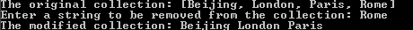

- Change line 8 of Example 27-2-5 to the following:
TreeSet<Circle> v=new TreeSet<Circle>(); //line 8
- Compile the program:
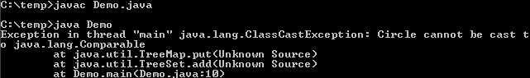

//Example 27-2-6
//Demo.java
import java.util.*;
public class Demo
{
public static void main(String[] args)
{
TreeSet<Circle> v=new TreeSet<Circle>(); //line 8
v.add(new Circle(2)); //line 9
v.add(new Circle(2)); //line 10
System.out.println(v);
if (v.remove(new Circle(2))) System.out.println("removed"); //line 12
else System.out.println("not removed");
}
}
class Circle implements Comparable<Circle>
{
private double radius;
public Circle()
{
radius = 0.0;
}
public Circle(double rad)
{
radius = rad;
}
public String toString()
{
return "Radius: " + radius;
}
public boolean equals(Object obj)
{
if (obj instanceof Circle)
{
Circle c=(Circle)obj;
if (radius==c.radius) return true;
else return false;
}
return false;
}
public int compareTo(Circle c)
{
if (radius==c.radius) return 0;
else if (radius<c.radius) return -1;
else return 1;
}
}
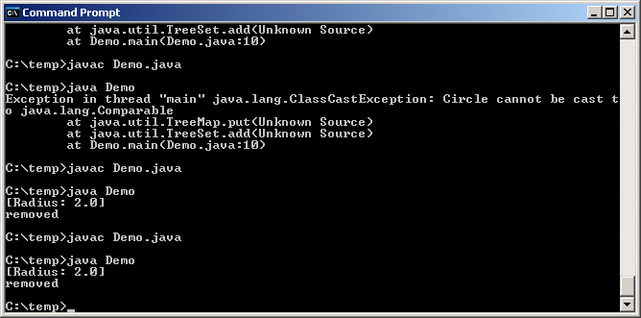

- Of course, a TreeSet possesses those methods specified in the SortedSet interface, which a HashSet does not possess.

//Example 27-2-7
//Demo.java
import java.util.*;
public class Demo
{
public static void main(String[] args)
{
TreeSet <String> ts = new TreeSet <String>();
ts.add("London");
ts.add("Paris");
ts.add("Rome");
ts.add("Beijing");
System.out.println(ts.first());
System.out.println(ts.last());
System.out.println(ts.headSet("Rome"));
System.out.println(ts.tailSet("Rome"));
}
}

Class Collections

----------------------------------------------------------------------------------------------------------------------------
Usage: public static <E> int binarySearch(List<? extends Comparable<? super E>> table, E key)
Return: The index of the search key, if it is contained in the list; a negative int otherwise
// List can take anything as long as it extends Comparable<E> or any superclass or E

Usage: public static void reverse(List<?> list)
Post: The order of the elements in the specified list reversed

Usage: public static void shuffle(List<?> list)
Post: The order of the elements in the specified list randomly rearranged.

Usage: public static void swap(List<?> list, int i, int j)
Post: The elements at positions i and j in the specified list swapped.

Usage: public static <E extends Comparable<? super E>> E min(Collection<? extends E> coll)
Return: The minimum element of coll, according to the natural ordering of its elements.
Throw: NoSuchElementException if coll is empty.

Usage: public static <E> E min(Collection<? extends E> coll, Comparator<? super E> comp)
Return: The minimum element of coll, according to the order induced by the specified comparator.
Throw: NoSuchElementException if coll is empty.

Usage: public static <E extends Comparable<? super E>> E max(Collection<? extends E> coll)
Return: The maximum element of coll, according to the natural ordering of its elements.
Throw: NoSuchElementException if coll is empty.

Usage: public static <E> E max(Collection<? extends E> coll, Comparator<? super E> comp)
Return: The maximum element of coll, according to the order induced by the specified comparator.
Throw: NoSuchElementException if coll is empty.

Usage: public static <E extends Comparable<? super E>> void sort(List<E> list)
Post: The specified list sorted into ascending order, according to the natural ordering of its elements.

Usage: public static <E> void sort(List<E> list, Comparator<? super E> c)
Post: The specified list sorted into ascending order, according to the order induced by the specified
comparator.
----------------------------------------------------------------------------------------------------------------------------
Figure 27-2-8. API for some methods in class Collections

//Example 27-2-8
//Demo.java
import java.util.*;
public class Demo
{
public static void main(String[] args)
{
Vector<Integer> v=new Vector<Integer>();
v.add(1);
v.add(2);
v.add(3);
System.out.println(v);
Collections.shuffle(v);
System.out.println(v);
Collections.reverse(v);
System.out.println(v);
}
}
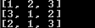

Programming Assignment

Example 27-2-6 allows us to use class TreeSet with Circle objects by modifying class Circle to implement Comparable. A second way to use class TreeSet with Circle objects is not to modify class Circle to implement Comparable but to write a Comparator class to compare Circles. Redo Example 27-2-6 using the second way.sp

Note:
- You need to add method getRadius to class Circle

Hand in/email:
- Demo.java

